**Exercise 3: Classify Customers Based on Postal Codes**

Create a PostgreSQL function called classify_customer_by_postal_code(postal_code VARCHAR) that returns Local, National, or International based on the pattern of the postal code (e.g., Local for codes like 12345, National for codes like 123-456, and International for other formats).

Test: Use this function in a query on the Customers table to classify customers and display the first 10 results.

-- Task_03.sql

-- Function to classify customers based on postal code format

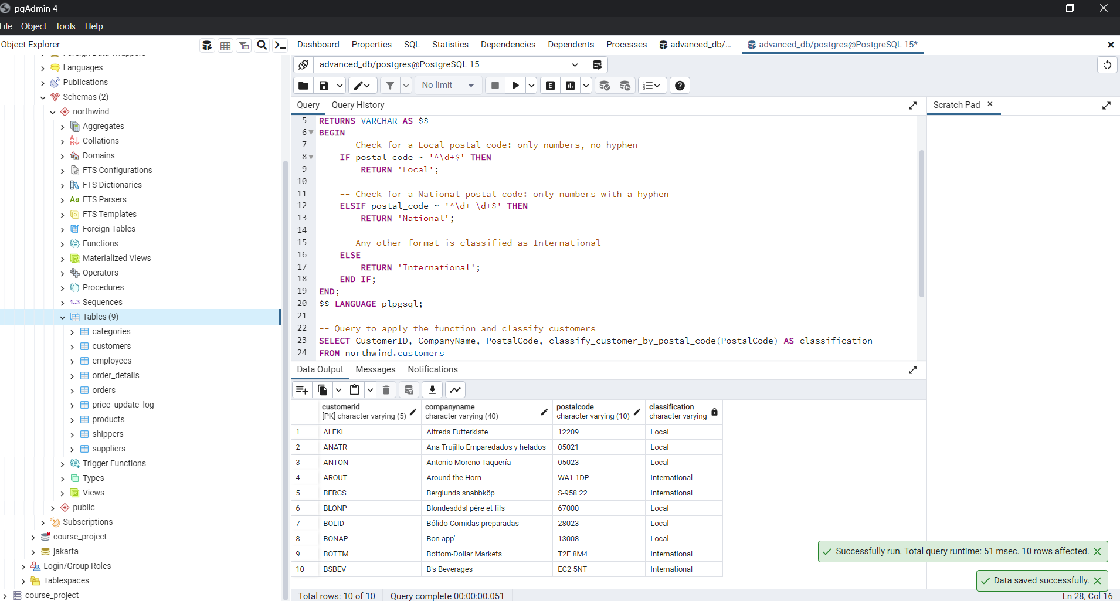

-- Explanation:

-- Local: Matches postal codes with exactly 5 digits (e.g., "12345").

-- National: Any postal code that contains a hyphen (`-`), regardless of the number of digits before or after it.

-- International: All other formats that don't match the above patterns.

And test with checking all not with limit

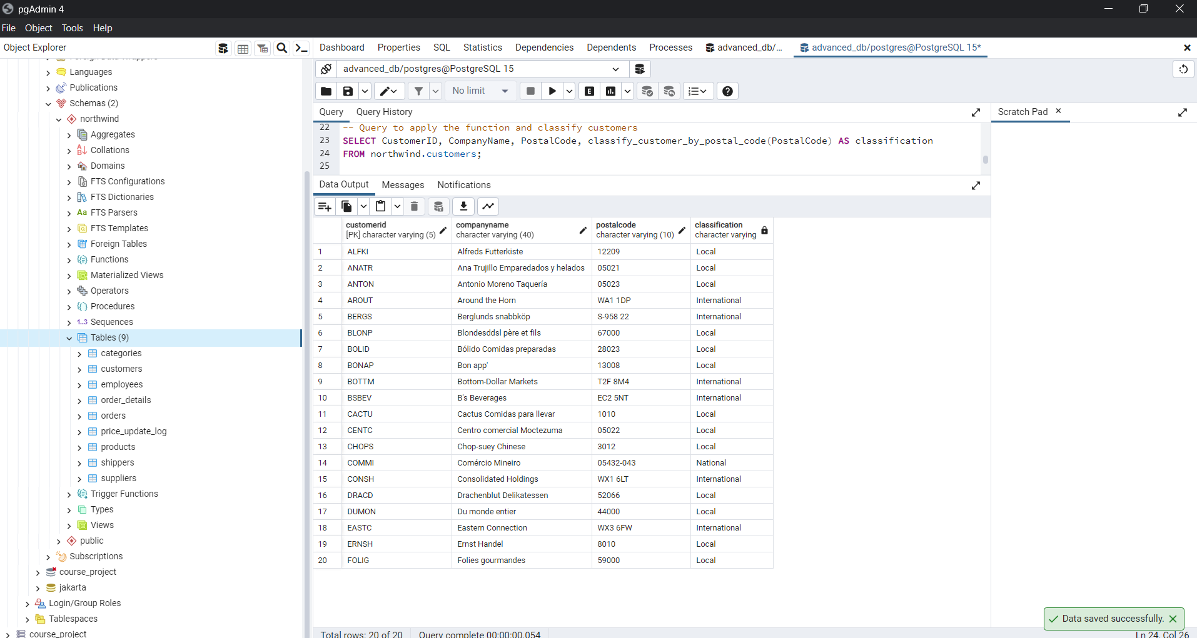

There is only 1 national number:

"12209" → Local (only numbers)

"05021" → Local (only numbers)

"05023" → Local (only numbers)

"WA1 1DP" → International (contains letters and spaces)

"S-958 22" → International (contains letters, hyphen, and spaces)

"67000" → Local (only numbers)

"28023" → Local (only numbers)

"13008" → Local (only numbers)

"T2F 8M4" → International (contains letters and spaces)

"EC2 5NT" → International (contains letters and spaces)

"1010" → Local (only numbers)

"05022" → Local (only numbers)

"3012" → Local (only numbers)

"05432-043" → National (contains only numbers with a hyphen)

"WX1 6LT" → International (contains letters and spaces)

"52066" → Local (only numbers)

"44000" → Local (only numbers)

"WX3 6FW" → International (contains letters and spaces)

"8010" → Local (only numbers)

"59000" → Local (only numbers)